About this hotel
Set on the Bay of Bengal, this relaxed beach resort is 56 km from Pathein Airport, a 12-minute walk from Tea Cup Rock and 2 km from Lovers Island.
Bright rooms provide Wi-Fi, TVs and minibars, as well as air conditioning and private bathrooms. Some rooms feature living areas and/or balconies. Room service is available 24 hours.
Breakfast is offered, and dining is available in an open-air restaurant. There's also an outdoor pool with sunloungers. Spa services, bike rentals and parking, as well as shuttle services, are available.
Check-in time: 14:00
Check-out time: 12:00

Address & contact information
Emerald Sea Resort, # 19Ngwe Saung - Sin Ma Road, Ngwe Saung Beach, Pathein Township
09 520 0890

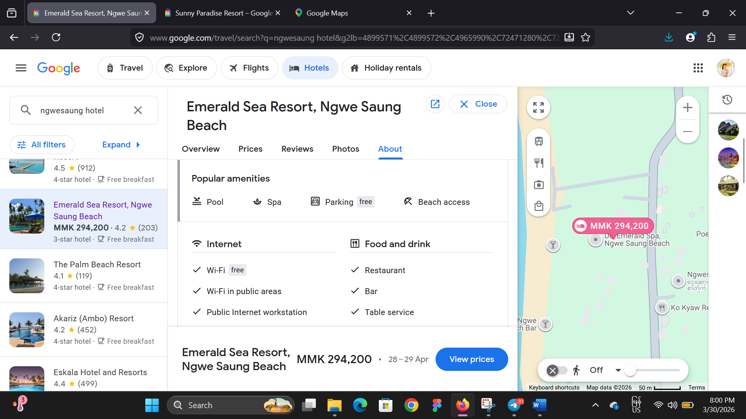

link

https://www.google.com/travel/search?q=ngwesaung%20hotel&g2lb=4899571%2C4899572%2C4965990%2C72471280%2C72560029%2C72573224%2C72647020%2C72686036%2C72803964%2C72882230%2C72958624%2C73059275%2C73064764&hl=en-MM&gl=mm&cs=1&ssta=1&ts=CAESCgoCCAMKAggDEAAaVAo0EjIyJTB4MzBiZTM1NTE2YTgxZDkwMzoweDcxYzRiYTA5Yzg3MjUwMjI6CU5nd2VzYXVuZxIcEhQKBwjqDxAEGBwSBwjqDxAEGB0YATIECAAQACoHCgU6A01NSw&qs=CAAgACgAMiRDaGNJcmRxMjhJYmdxcllwR2dzdlp5OHhkSEJpT0dSNGVSQUI4DUgA&ap=KigKEgmSCD3K29YwQBFwVBMVB5lXQBISCUFYVsA72DBAEXBUE71AmVdAMAC6AQdkZXRhaWxz&ictx=111

